CREATIVE SKILLS, RELATIONSHIPS AND BEHAVIOURAL MANAGEMENT COURSES

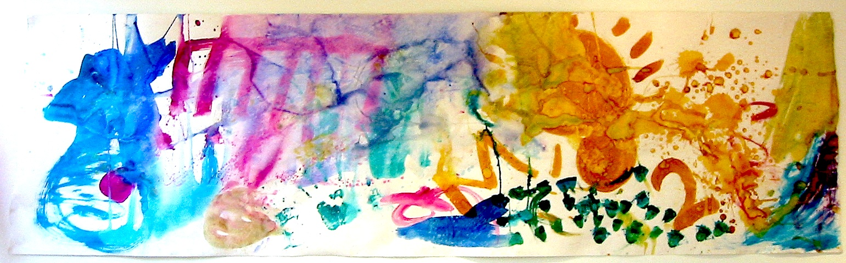

Child Trauma and behavioural management Training
Young People’s safety awareness workshops
Parent Training
Professional Workforce Development skills Training

MANAGING CHILDREN’S ANGER

Aims
To develop strategies in order to understand, manage and help children release destructive and angry emotions

Outcomes
Understand conflict related vocabulary versus peaceful vocabulary
Learn creative methods in supporting children to release strong emotions using mediums of clay, role play and stories
Identify appropriate aggressive behaviours’ and triggers to anger

CONLICT RESOLUTION WITH TEENS –
Aims:
Participants will learn fundamental skills related to conflict Resolution helping young people to build a repertoire of positive strategies for resolving conflict.

Outcomes
Introduction to conflict management styles
Develop skills in helping young people how to handle put downs, negotiate win-win situations
Learn how to help young people to identify personal sources of conflict examining conflict communication

INTRODUCTION TO CREATIVE COUNSELLING SKILLS

Aims
To develop skills in Basic Counselling using creative media to explore dialogue, problematic situations and non verbal communications.

Outcomes:

You will develop knowledge of key aspects of counselling
Considering Carl Rogers theory Combined with drawing on the healing potential of Natalie Roger’s Person Centred Expressive Arts and the conditions that foster creativity.
You will learn key skills of active listening, questioning, observation and empathy developing knowledge of the goals for counselling children.

INTRODUCTION TO THERAPEUTIC PLAY SKILLS-

Aims
To learn a variety of play therapy techniques learning ways in which children express emotion through creative media

Outcomes
Develop knowledge of the principles of a person centred child therapy developing skills in referral contracting and assessment processes and how to evaluate a child’s progress by using Goodman’s scoring questionnaires.
Engage with creative activities in the exploration of self
Learn how to help a child address specific problematic issues considering the meanings that symbolic imagery hold for a child.

SUPPORTING CHILDREN FROM VIOLENT HOMES

Aims
Workers will learn about the impact of exposure to domestic violence on child development learning strategies for supporting children who are displaying troubling behaviours.

Outcomes
You will develop knowledge of Eriksons Theory of Psycho-social development identifying major crises that children display and strategies necessary for healthy development.
Learn skills in safety planning, recording concerns and supporting children to emotionally process feelings around their trauma using creative techniques

CREATIVE RESPONSES TO CHILDHOOD ABUSE
Aims
Participants will learn creative interventions to enable children to develop resilient responses encouraging post traumatic growth after exposure to abusive experiences

Outcomes
Participants will develop knowledge of traumatic dynamics and issues impacting on a child’s development learning ways in how to handle disclosures developing skills in safety planning techniques and how best to respond and support children transitioning through abuse

SUPPORTING YOUNG PEOPLE STRUGGLING WITH MENTAL HEALTH
Aims
To raise awareness of mental health issues and early warning signs of mental distress in children promoting well being and resilience encouraging self help strategies for children and their families.
Outcomes
Develop knowledge of children’s mental health disorders, and how it can be accommodated with school based, psychological, home and family intervention.

CREATIVE GROUPWORK PRACTICE WITH CHILDREN
Aims
Participants will develop knowledge of practice perspectives and considerations in setting up and delivering creative group-work for children gaining a range of knowledge of creative interventions to support children experiencing emotional trauma.

Outcomes
Participants will learn skills, processes and creative techniques that can be used in setting up basic loss, friendship and domestic violence groups

Young People’s Safety Awareness Workshops
Parent Training

SUPPORTING TEENS IN EXPLOITATIVE SITUATIONS

Aims:
This training will support parents to talk to young people about developing positive healthy relationships raising awareness of the risks of sexually exploited youth and the consequences of being groomed

Outcomes:

Develop knowledge around abusive relationships identifying signs of emotional grooming
How to support young people protect them selves and stay safe
To develop awareness in how to enable young people apply the 12 steps of physical closeness in healthy relationships
To explore personal boundary setting

SUPPORTING TRAUMATISED CHILDREN

Aims:
This training will support parents to talk to children and engage with them using creative techniques to support recovery from abuse.

Outcomes:
Will learn creative strategies to support children build resilience and stay safe
Identify the impact that abuse has on child development
Develop skills in listening, empathising and sensitively reflecting
Learn effective strategies for boundary setting and taking about healthy relationships

CPD -SUPPORTING TEENS IN EXPLOITATIVE SITUATIONS

Aims
This training will provide healthcare professionals, teachers, and frontline teams skills in understanding and responding to young people in exploitative situations and preventative strategies around keeping themselves safe from abuse

Outcomes

Identify risks and increase protective factors around dating for young people
To recognize grooming tactics and boundary violation in relationships
Understand consequences of young people being exploited
Identifying distorted thinking patterns and language used by perpetrators
Develop knowledge of Good practice guidelines on safe guarding and signposting to appropriate agencies

CPD workforce development skills Training for professionals

DEALING WITH DIFFICULT PEOPLE- 1 or 2 day course

Aims:
To explore difficult situations and our responses to them considering the impact on our work and interpersonal relationships.

Outcomes:
To define conflict and approaches to it and develop knowledge of the nature and stages of the conflict process examining your own conflict management styles.
Identify the seven factors associated within the circle of conflict that might affect performance feedback and lead to conflict ridden conversations.
Address fears associated with hard to manage individuals within behaviours you find difficult.
Develop skills in assertion and communication techniques around questioning, active listening how to handle criticism

ART APPROACHES TO ANGER AND CONFLICT

Aims
To explore approaches to anger using creative ways to explore and address it.
Outcomes

Share our understanding and experience of conflict
Explore and make visible the elements of conflict through expressive mediums such as painting, clay-work, sculpting and drawing.

Develop skills to support individuals to express and release difficult emotions through using art techniques in creative expression.

INTRODUCTION TO CREATIVE TECHNIQUES IN COUNSELLING
Aims
To develop skills in Basic Counselling using creative media to explore dialogue, problematic situations and non verbal communications.

Outcomes:

You will develop knowledge of key aspects of counselling
Considering Carl Rogers theory Combined with drawing on the healing potential of Natalie Roger’s Person Centred Expressive Arts and the conditions that foster creativity.
You will learn key skills of active listening, questioning, observation and empathy developing knowledge of the goals for counselling

SKILLS IN THE DYNAMICS OF GROUPWORK PRACTICE

Aims:
Participants will develop knowledge of how to set up and run group considering group dynamics and processes, identifying key skills in facilitation and different stages a group has to go through in order to function successfully.

Outcomes:
Explore the stages/processes a group has to go through in order to function successfully
Develop knowledge around factors that could influence group involvement- roles people play in groups
Understand types of trainee resistance
Learn how group dynamics and processes affect performance behaviours, and learning

ASSERTION SKILLS

Aims:
Recognise the difference between assertion, non assertion and aggression and to be able to use assertive behaviours of making and refusing requests, handling criticism or conflict more constructively.

Objectives:
To develop knowledge of the dimensions of assertive behaviour exploring situations that you wish you could be more assertive about and how to deal with put downs .

CONFLICT MANAGEMENT
Aims:
To enable participants with knowledge and skills to deal with a range of challenging behaviour recognising types of interpersonal and work related conflict.

Objectives:
To define conflict and approaches to it
To provide an outline of the conflict management process
To identify what happens to us when we are under threat exploring triggers to behaviours
To assess our verbal and non verbal communication styles.
Develop skills in conflict reduction, negation and problem solving

All courses are experientially based some involving creative skills based practice.
For more information contact Jan on 0113 2175235 mobile: 07581140696
www.createtorelate.co.uk

About the Trainer- JAN HAGHVERDI

These courses are run by Jan Haghverdi, a Training Consultant Therapeutic Manager, Counsellor, Child Therapist Lecturer and trainer with fourteen years experience of working with groups, families and children and young people’s services. Jan presently works as a School project Manager running a Therapeutic project for children with emotional and behavioural problems and also Co-ordinates a counselling Service In a college of Further Education for students. Jan has had 14 years teaching experience previously developing creative arts modules/ CPD training for Bradford University, courses for Cruse and training for medical students in the NHS. Recently she delivered training courses for Northorpe Hall Child and Family Trust NCCUK sure start and Kirklees Social Services Staff teams.
She has worked as a community development coordinator running a domestic violence project and has been a mental health advocate for children, families and vulnerable adults for over 14 years.

Jan has a keen interest in the emotional and behavioural development of children, young people and adults. She has supported children and clients who have been abused, been placed in care, experienced mental ill-health, drug and alcohol issues and others who have suffered post traumatic effects of witnessing domestic abuse or neglect.

Jan develops and delivers emotional/mental health awareness training, in FE and Higher Education and offers clinical and line management supervision. She continues to work with colleges, schools, NHS, Social Services and charities to develop and deliver training and improve practice.

See www.createtorelate.co.uk for more details of Jan’s work.

Mobile: 07581140696

